**Red Team Capstone**

**Project**

Justin Smith

4/8/2020

**Finding the IP address**

-Running Ifconfig so we could find the IP address on eth0

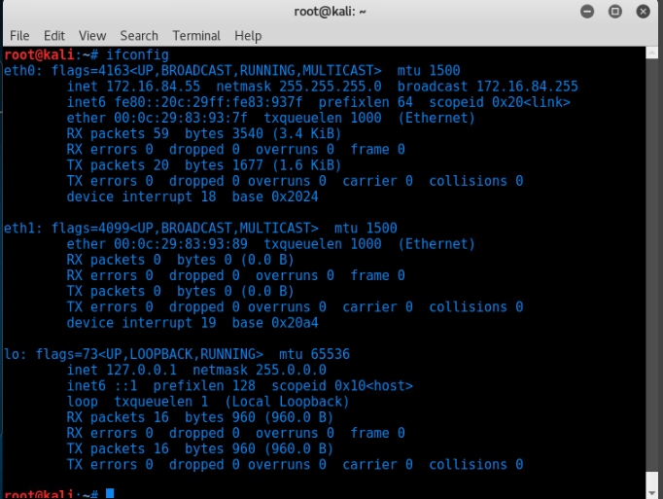

**Starting metasploit to run nmap**

* Running > db_nmap 172.16.84.55
* Found open ports on
* 22 (ssh)
* 80 (http)

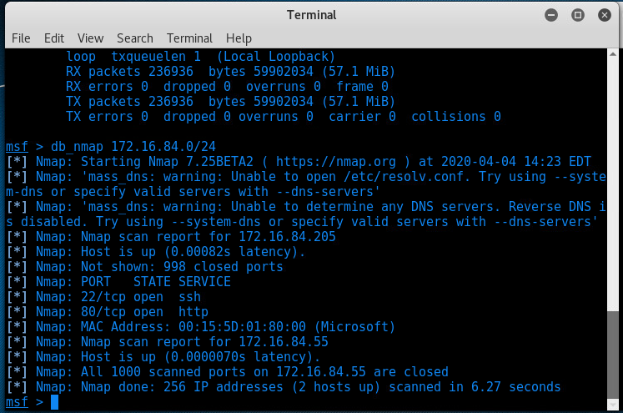

**Opening Firefox**

- We put the IP into firefox and found a website.

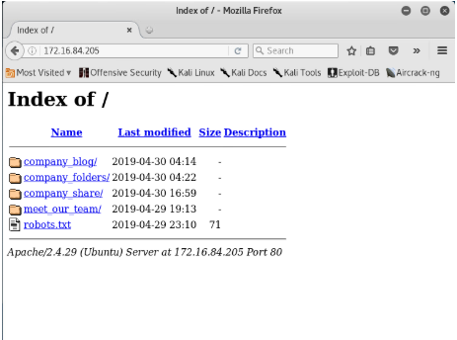

**Found that there was a secret folder**

- Located in the company_folder/customer_folder

- 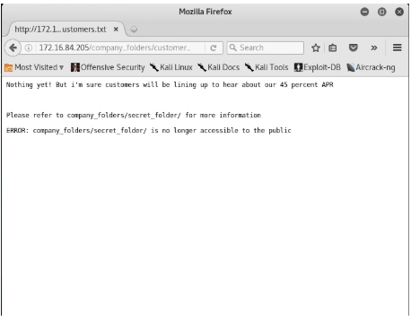

**Finding user Ashton**

- While digging around we found that there is a user named Ashton.

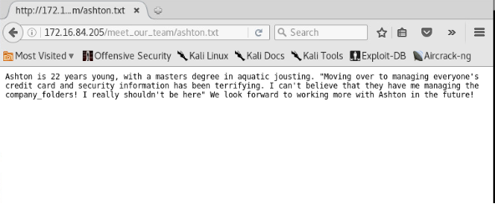

**Starting a Hydra attack on user Ashton to brute force his password**

- using command # hydra -l ashton -P /usr/share/wordlists/rockyou.txt -s 80 -f -vV 172.16.84.205 http-get /company_folders/secert_folder

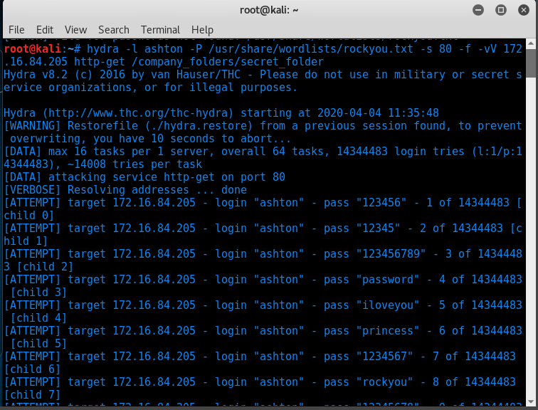

**Results of hydra**

- login: ashton

-password: leopoldo

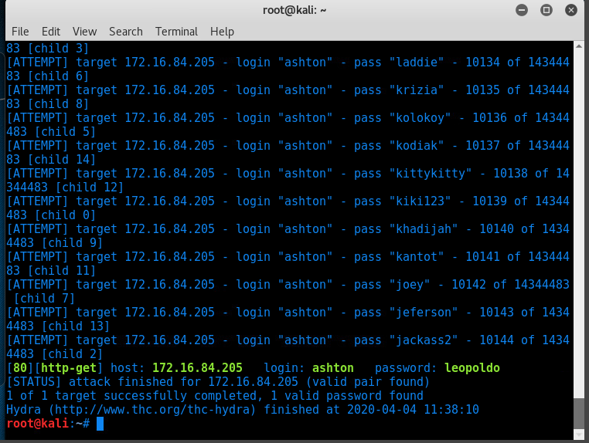

**Gaining access**

- The hydra attack worked and we got access to the secret folder

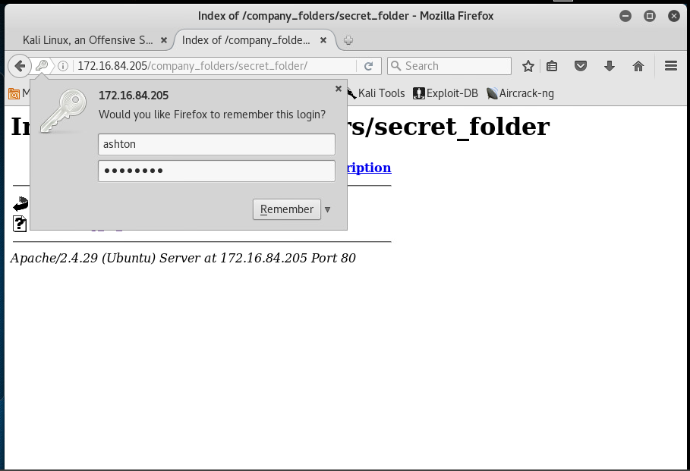

**Finding Ryan’s hash**

- Found Ryan’s salted hash 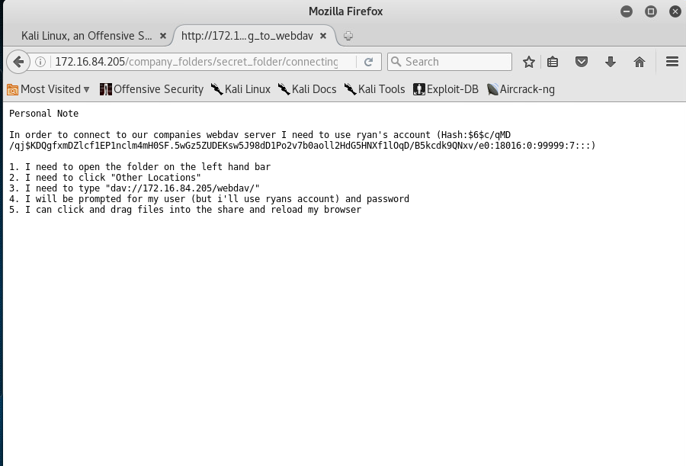

**Running John the Ripper**

- Opened nano and inserted ryan’s salted hash the named it “crackthishash”

- Started John the Ripper

- john --wordlist=/usr/share/wordlists/rockyou.txt crackthishash

- It returned Ryan’s password as “linux4u”

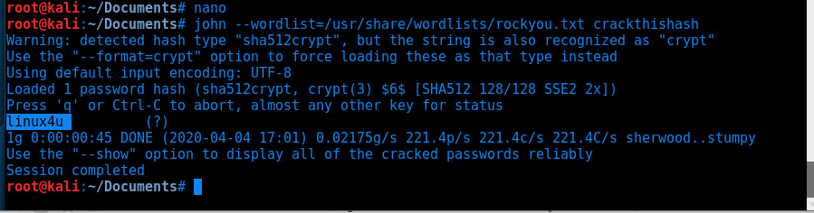

**Access gaind**

- Access gained to webdav by using user: ryan password: linux4u

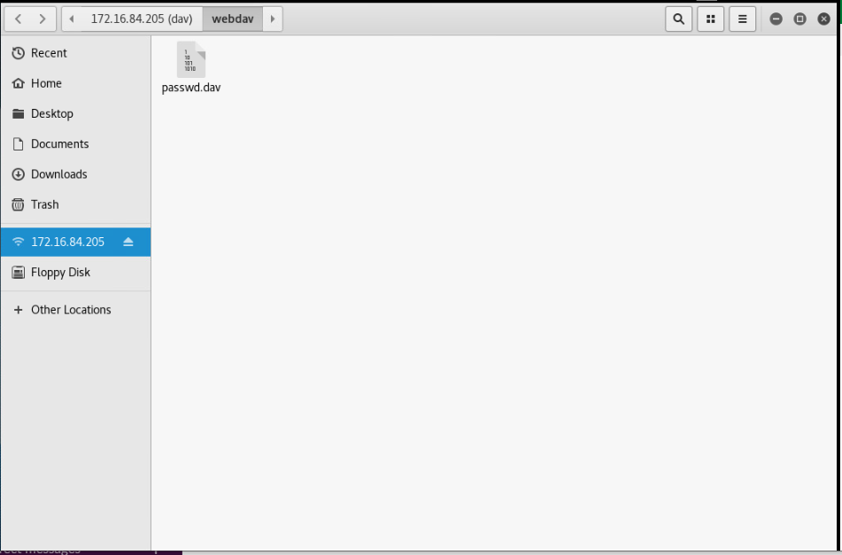

**Creating a reverse shell**

- Using Msfvenom to create shell.php

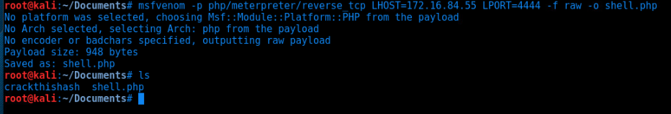

## **Start our meterpreter session**

-Meterpreter to use a reverse tcp exploit

-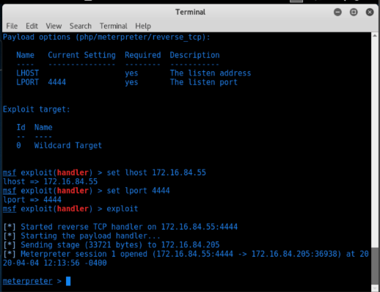

**Placing the shell**

-Shell.php was placed into webdav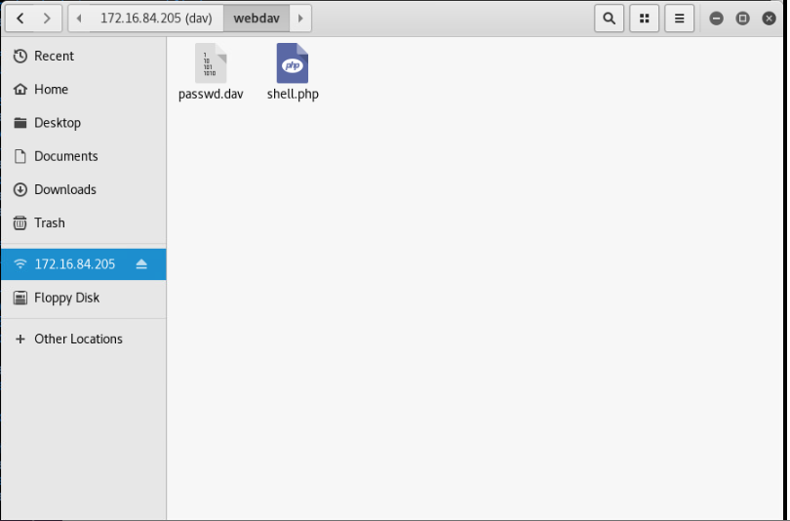

**Capture the flag**

- Searched meterpreter for flig.txt

